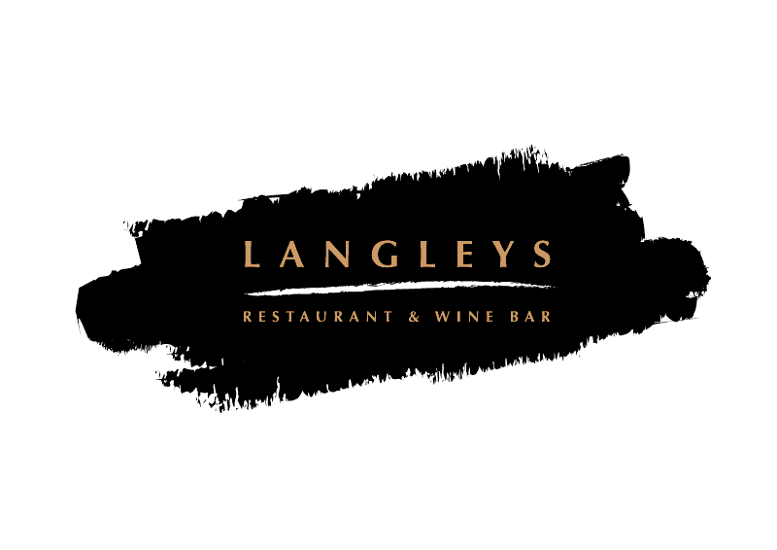Valentine’s Day
4 Course Meal £39.50 per person

STARTERS
Roasted apple and celeriac soup, Toasted Sourdough (Vv)
Gressingham smoked Duck and poached plum salad, dandelion, red wine reduction (Gd)
Devon crab arancini, brown crab mayonnaise, sea vegetable, lemon oil

MAIN COURSE
Sesame crusted Salmon fillet, Sticky Jasmine Rice, Bok Choy, teriyaki jus (dg)
New seasoned herb crusted lamb rack, gratin potatoes, maple glazed carrots,
red currant jus(g) (£8 supplement)
Tiger prawns and chorizo tagliatelle, samphire, confit garlic, chilli, lemon oil
Grilled & spiced cauliflower steak, dressed courgette, provincial vegetable, tahini
Dressing (Vvg)

DESSERTS
English rhubarb and apple crumble, vanilla ice cream/custard (vg)
Tiramisu, Coffee Syrup, Hazelnut and Chocolate soil (v)
Dark Chocolate & Cherry brownie, raspberry coulis, honey comb ice cream

Tea / Coffee and Petit Fours

